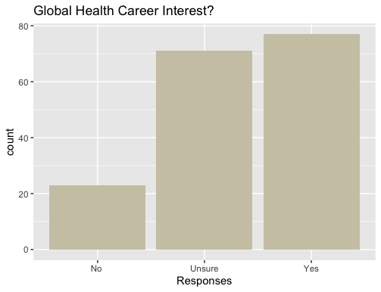

No: 23

Unsure: 71

Yes: 77

1st Year: 30

2nd Year: 72

3rd Year: 45

4th Year: 21

5th Year: 3



18-20: 148

21-23: 19

24-26: 4



No: 150

Yes: 21



No: 143

Yes: 28



|  |  |  |
| --- | --- | --- |
| 1st year | No | 4 |
| 1st year | Unsure | 14 |
| 1st year | Yes | 12 |
| 2nd year | No | 10 |
| 2nd year | Unsure | 29 |
| 2nd year | Yes | 33 |
| 3rd year | No | 6 |
| 3rd year | Unsure | 18 |
| 3rd year | Yes | 21 |
| 4th year | No | 3 |
| 4th year | Unsure | 8 |
| 4th year | Yes | 10 |
| 5th year | Unsure | 2 |
| 5th year | Yes | 1 |



|  |  |  |
| --- | --- | --- |
| 18-20 | No | 21 |
| 18-20 | Unsure | 60 |
| 18-20 | Yes | 67 |
| 21-23 | No | 2 |
| 21-23 | Unsure | 9 |
| 21-23 | Yes | 8 |
| 24-26 | Unsure | 2 |
| 24-26 | Yes | 2 |



|  |  |  |
| --- | --- | --- |
| No | No | 23 |
| No | Unsure | 65 |
| No | Yes | 62 |
| Yes | Unsure | 6 |
| Yes | Yes | 15 |



|  |  |  |
| --- | --- | --- |
| No | No | 22 |
| No | Unsure | 64 |
| No | Yes | 57 |
| Yes | No | 1 |
| Yes | Unsure | 7 |
| Yes | Yes | 20 |